**Green Warrior**

**The Platformer**

**Project Report**

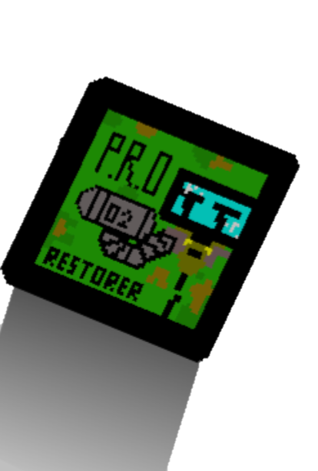

**Game By**

CR3ATIVEC0D3RS

[**https://encr.pw/greenwarrior**](https://encr.pw/greenwarrior)



Table of Contents

1. Introduction 3

2. Idea / Concept 3

4. The Project Team 4

4.1 Itti Ranjith- Lead Programmer 4

4.2 Ashley – Programmer and poster designer 4

4.3 Wesley – Programmer and poster designer 5

4.4 Jayden – Programmer, and slides designer 5

4. Rules of the Game 5

5. User Manual 6

5.1 Welcome Page 6

5.3 Game Controls 7

5.4 Gameplay Screenshots 7

6. How We Created the Game 12

6.1 Brainstorming and Conceptualization 12

6.2 Division of Roles and Collaborative Efforts 12

6.3 Overcoming Challenges 13

6.4 Celebrating Completion 13

7. Artwork Section 14

8. Source Code Samples 14

6. Acknowledgements 15

## 1. Introduction

Welcome to "Green Warrior," an exciting game a team of aspiring game developers from **Yu Neng Primary School** using the Scratch platform. The production version of the game is now publicly available online, and you can access it at the following URL: <https://scratch.mit.edu/projects/840626837/fullscreen/>

"Green Warrior" has made remarkable progress and has recently achieved recognition in Singapore's **NPGC3 (National Primary Games Creation and Coding Competition)**, a prestigious event dedicated to primary school kids. Out of numerous entries, "Green Warrior" successfully advanced to the final rounds, securing a place among the top 30 outstanding projects. <http://npgcc.org/?page_id=58>

The "Green Warrior" game is more than just a fun and adventurous experience. It carries a powerful message of environmental conservation and emphasizes the importance of restoring our planet. Through engaging gameplay, players embark on a mission to save the Earth from a dire state and bring it back to life.

At the heart of the game lies the 3R principle: **Reduce**, **Reuse**, and **Recycle**. By promoting these principles, "Green Warrior" aims to raise awareness among players about the critical role they can play in protecting our environment. By integrating these principles into the gameplay mechanics, the game teaches players that every small action can make a big difference in creating a sustainable future for our planet.

In this documentation, you will find all the information you need to know about the game, its concept, gameplay, and the creative process behind its development.

In the spirit of collaboration and knowledge sharing, the dedicated team behind 'Green Warrior' has made the source code of the game available as an open-source project on GitHub. This means that fellow game enthusiasts, developers, and aspiring programmers can access and explore the code, contributing to its improvement or even creating their own versions of the game. By sharing the source code, the team aims to foster creativity, inspire others, and promote the values of teamwork and community. You can find the 'Green Warrior' project on GitHub at <https://github.com/itti-ranjith/green-warrior>. Feel free to join the community, contribute to the project, or simply explore the inner workings of this inspiring game

## 2. Idea / Concept

The idea for "Green Warrior" emerged from the deep concern and love for our planet shared by the team. We wanted to create a game that would not only entertain players but also inspire them to take action in safeguarding our environment.

The initial spark for the game came from observing the global environmental challenges we face today, such as climate change, pollution, and deforestation. The creators realized that raising awareness among people, especially the younger generation, was crucial in bringing about positive change.

With this in mind, the concept of "Green Warrior" was born. The game is designed as an exciting adventure that takes players on a journey to restore the planet, level by level. By playing through different stages, the player becomes the protagonist, the Green Warrior, whose mission is to save the Earth from the brink of disaster.

Throughout the game, players encounter various obstacles, and challenges that symbolize the real-world environmental issues we face. The concept of using gameplay to address these challenges was developed to engage players actively in the process of saving the planet

The ultimate goal in "Green Warrior" is to reach the final stage, where the Earth can be restored to its former beauty. This significant milestone represents the collective effort and determination of the players in overcoming the obstacles that threaten our planet. As the final stage is completed, the background transforms from a desolate, red/brown landscape to a vibrant, green and beautiful Earth, signifying the successful restoration of the planet.

By combining a captivating gaming experience with a strong message of environmental responsibility, "Green Warrior" aims to inspire players to become real-life heroes in protecting and preserving our precious planet.

## 4. The Project Team

The "Green Warrior" game was brought to life by a talented team of young game developers **“CR3ATIV3COD3RS”** from **Yu Neng Primary School**. Let's meet the team members and learn about their roles and contributions to the project.



### 4.1 Itti Ranjith- Lead Programmer

Itti is the driving force behind the development of "Green Warrior." With five years of experience in learning and experimenting with Scratch, Itti is an expert in the Scratch language and platform. Though Itti had some prior experience with programming languages like Java and Python, they developed a special affinity for Scratch due to its simplicity, visual coding capabilities, and ease of structuring the flow.

As the lead programmer, Itti meticulously worked on the project, ensuring that the gameplay mechanics, character movement, and level design were all seamlessly integrated. They coordinated with the team members, gathered their ideas, and implemented them effectively in the game. Itti's expertise in Scratch programming allowed them to translate their vision into a fully functional and engaging game.

### 4.2 Ashley – Programmer and poster designer

Ashley was responsible for creating captivating character designs that embodied the spirit of the Green Warrior and other in-game personas. His artistic flair and attention to detail resulted in visually stunning characters that players can connect with throughout gameplay experience.

He focused on designing breath-taking level backgrounds that transported players into different environments, ranging from lush forests to arid deserts. His mastery in creating immersive backdrops enhanced the overall atmosphere of the game, immersing players in the world of the Green Warrior.

### 4.3 Wesley – Programmer and poster designer

Wesley, a skilled programmer and poster designer, played a pivotal role in shaping the gameplay experience of "Green Warrior." As a designer, Wesley meticulously crafted the various levels, puzzles, and challenges that players encounter on their heroic journey. With a keen eye for engaging gameplay mechanics and a knack for creating thought-provoking puzzles, Wesley ensured that each stage presented a unique and exciting obstacle for players to overcome. His dedication to creating immersive and captivating levels added depth and replay value to the game, keeping players engaged and motivated as they strive to restore the planet.

### 4.4 Jayden – Programmer, and slides designer

Jayden, a talented programmer and slides designer, played a critical role in ensuring the quality and polish of "Green Warrior." As the dedicated tester, Jayden tested every aspect of the game, meticulously playing through each level and closely examining the mechanics, controls, and overall gameplay experience. His keen eye for detail allowed him to identify any issues or areas for improvement, providing valuable feedback to the team. Jayden's dedication to playtesting and their commitment to delivering a seamless and enjoyable gaming experience proved invaluable in refining the game and making it even more engaging for players.

## 4. Rules of the Game

To successfully navigate the world of "Green Warrior" and restore the planet, players must adhere to the following rules:

1. **Objective**: The goal is to complete each level by overcoming obstacles, solving puzzles, and reaching the endpoint to save the planet Earth.
2. **Controls**: Use the WASD keys or arrow keys to control the Green Warrior's movement. Pressing the 'W' key or the up arrow key will make the character jump.
3. **Avoid Obstacles**: Be cautious of environmental hazards, such as spikes, pits, as coming into contact with them will cost the player a life. Losing lives will result in restarting the level.
4. **Strategy**: Plan your moves carefully and think strategically to overcome challenges. Some puzzles may require interaction with objects or switches in the environment to progress.
5. **Infinite Trials**: Players have an infinite number of trials in each stage, allowing them to explore and learn from their mistakes without any time pressure. This encourages everyone to participate in the effort of saving the planet.

## 5. User Manual

"Green Warrior" consists of multiple levels, each offering unique challenges and puzzles. Your ultimate mission is to reach the end of the game and save the planet in danger of being covered with trash.

This section will provide you with step-by-step instructions on how to play the game and guide you through the exciting gameplay experience. Let's get started!

### 5.1 Welcome Page

Before immersing yourself in the thrilling world of "Green Warrior," you will be greeted with a short animation that serves as an introduction to the game. This introduction serves as a warm welcome and aims to familiarize you with the game's purpose and rules.

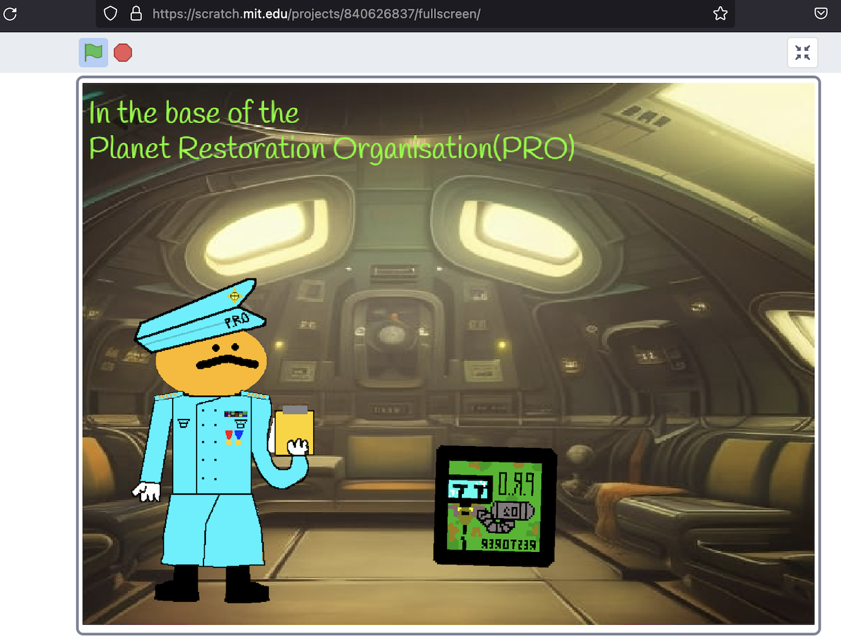

During the introduction, the organization will present important information about the urgency of saving the planet and the role you, as a Green Warrior, play in this mission. They will emphasize the three principles of environmental conservation: reduce, reuse, and recycle. By following these principles, we can work together to restore our planet's health and preserve it for future generations.

### 5.3 Game Controls

To control the Green Warrior and navigate through the levels, use the following controls:

* Use the WASD keys or arrow keys to move the Green Warrior left, right, up, or down.
* Press the 'W' key or the up arrow key to make the Green Warrior jump over obstacles and reach higher platforms.

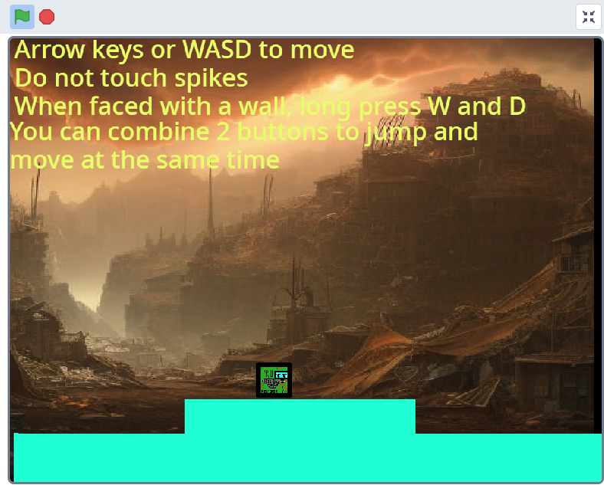

### 5.4 Gameplay Screenshots

To help you visualize the gameplay, here are some screenshots that showcase different levels and challenges:

#### MODERATELY EASY LEVELS

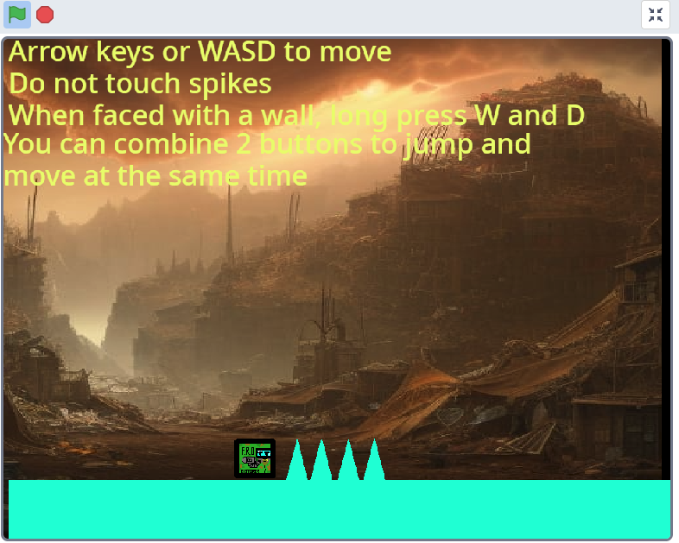

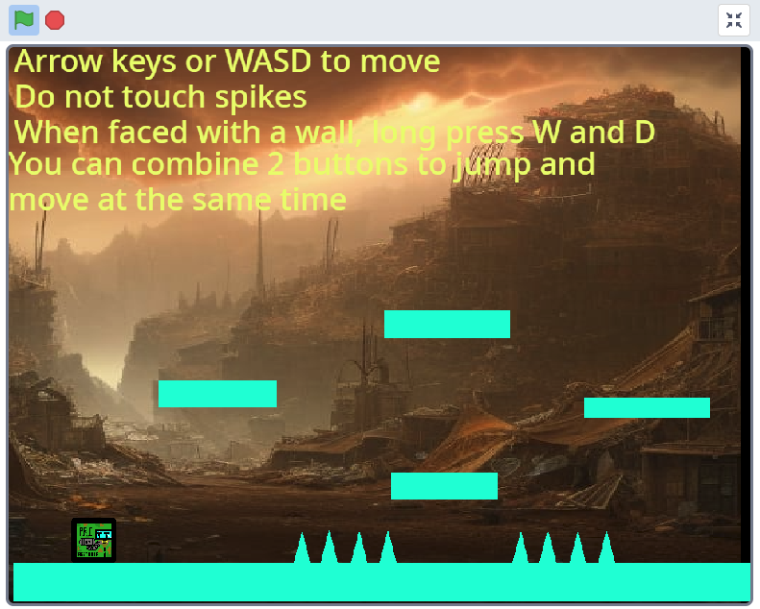

#### Medium Levels

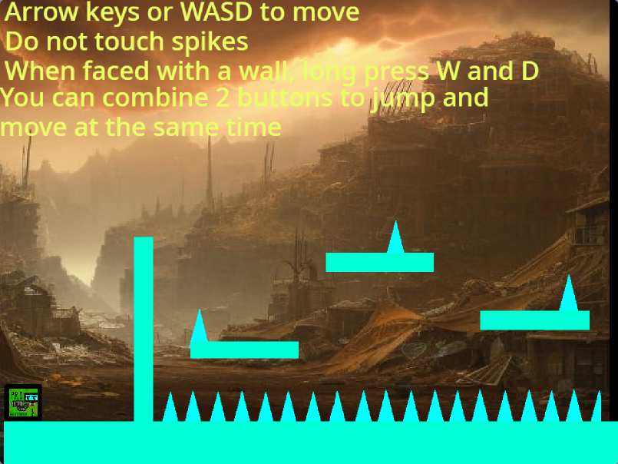

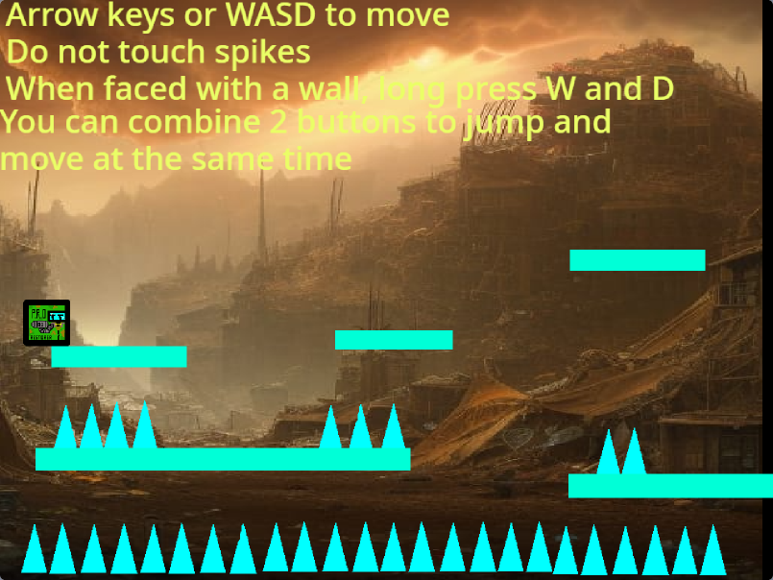

#### Harder levels

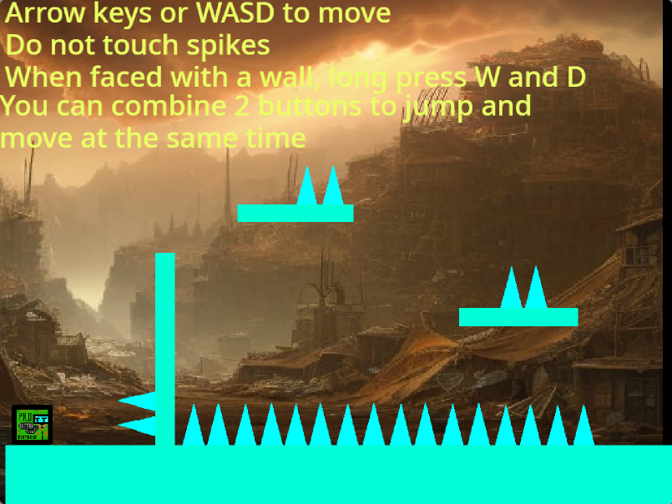

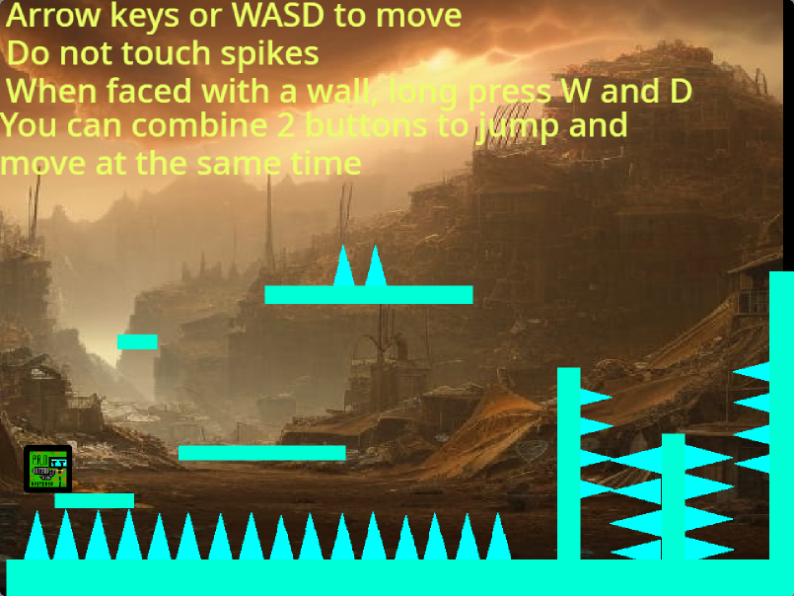

#### Final step

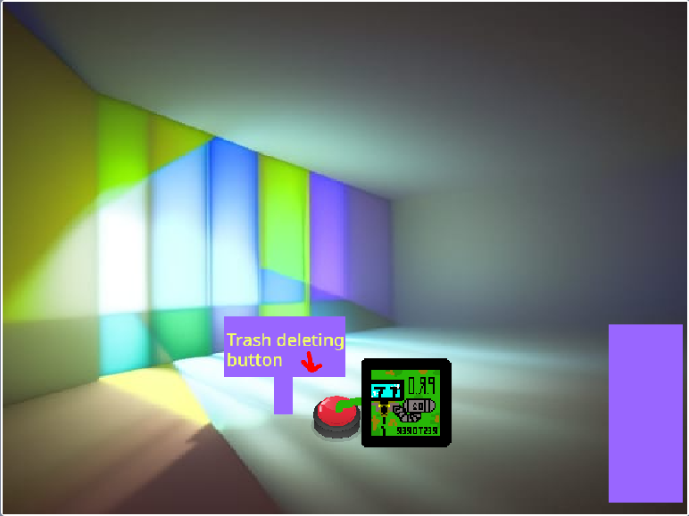

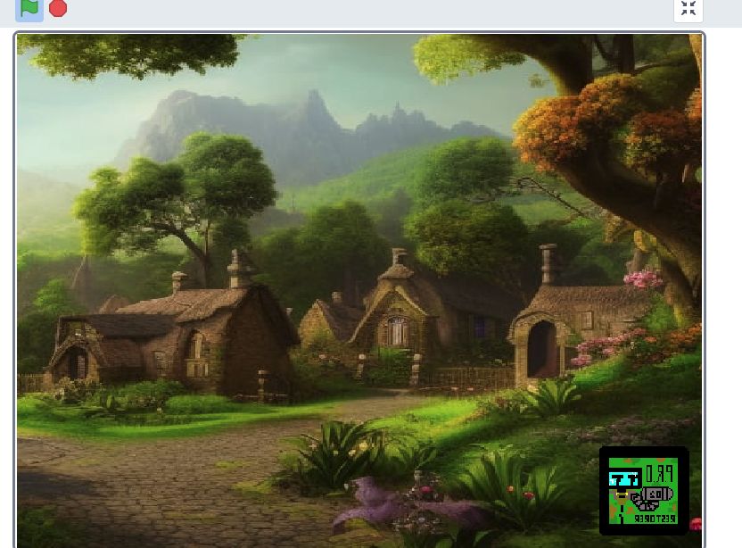

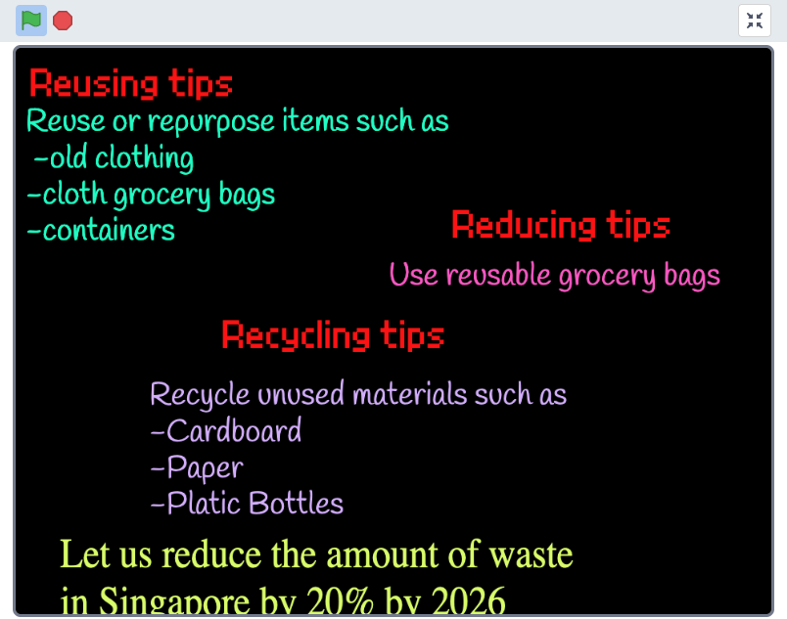

## 6. How We Created the Game

Creating "Green Warrior" was a collaborative and exhilarating journey for our team. Over a span of two months, we worked diligently to bring this game to life and deliver an immersive experience that promotes the values of environmental conservation. Here's an insight into our creative process and the challenges we faced along the way:

### 6.1 Brainstorming and Conceptualization

The initial phase of creating "Green Warrior" involved brainstorming sessions where we shared ideas and explored different concepts. Inspired by the urgency to protect our planet, we decided on a game that allows players to actively participate in the restoration process. The concept of playing through different levels, symbolizing stages of environmental recovery, emerged as the central theme.

### 6.2 Division of Roles and Collaborative Efforts

To ensure smooth progress, we divided responsibilities based on our individual strengths and interests. The team consisted of passionate individuals, each contributing their unique skills to the project. With years of experience in learning and experimenting with Scratch, we provided invaluable insights to one another, help structure the game's flow by utilizing visual coding through block programming in scratch.

Throughout the development process, our team maintained close collaboration and regular communication. We scheduled frequent meetings to discuss progress, address challenges, and share ideas. This teamwork allowed us to leverage each other's strengths and navigate through complex tasks efficiently.

### 6.3 Overcoming Challenges

While creating "Green Warrior," we encountered various challenges that tested our problem-solving abilities. One notable hurdle was designing engaging levels that strike a balance between difficulty and enjoyment. We wanted to provide a challenging experience while ensuring players of all skill levels could progress. Through continuous playtesting and feedback sessions, we fine-tuned the level design, adjusting obstacles, platform placements, and puzzle complexity to create a rewarding gameplay experience.

Additionally, as with any project, we faced technical hurdles along the way. Bugs and glitches occasionally surfaced during development, but our team tackled them head-on. Itti, our lead programmer, meticulously worked on debugging, conducting several rounds of unit testing, and fixing issues promptly. The collective effort of the team in identifying and resolving technical challenges ensured the smooth operation of the game.

### 6.4 Celebrating Completion

After months of dedication and hard work, we successfully completed "Green Warrior." The feeling of accomplishment was overwhelming as we witnessed our vision materialize into an interactive and impactful game. We took pride in the fact that we created a game that not only entertains but also educates players about the importance of environmental sustainability.

Throughout the development process, we fostered a supportive and encouraging environment, motivating each other to overcome obstacles and maintain our enthusiasm. The result is a game we are proud to share with the world, hoping to inspire players of all ages to take action in preserving our planet.

## 7. Artwork Section

"Green Warrior" features captivating artwork that brings the game to life and enhances the player's immersive experience. Our talented team of artists poured their creativity and passion into creating stunning visuals that resonate with the game's theme of environmental restoration. Let's explore the incredible artwork crafted for "Green Warrior":

The characters in the game have been meticulously illustrated to reflect the spirit of the Green Warrior and their mission to save the planet. Each character is unique, with their own distinctive traits and personality traits that players can connect with throughout their journey.

One exciting aspect of our artwork creation process was the utilization of AI (Artificial Intelligence) to generate certain elements. We employed AI algorithms to assist in the generation of intricate environmental details, such as foliage patterns and terrain variations. This approach enabled us to expedite the creation process while maintaining a high level of visual quality.

## 8. Source Code Samples

In this section, we will provide you with a glimpse into the source code of "Green Warrior." The game was developed using the Scratch programming platform, which offers a user-friendly and visual approach to coding. Here, we will explore how different components of the game were coded, giving you insights into the behind-the-scenes magic that brings "Green Warrior" to life.

The movement mechanics of the Green Warrior were implemented using Scratch's built-in motion blocks. By assigning specific key inputs to corresponding movements, such as arrow keys or the WASD keys, we enabled players to control the character's movement smoothly. Through experimentation and fine-tuning, we achieved a responsive and enjoyable player experience.

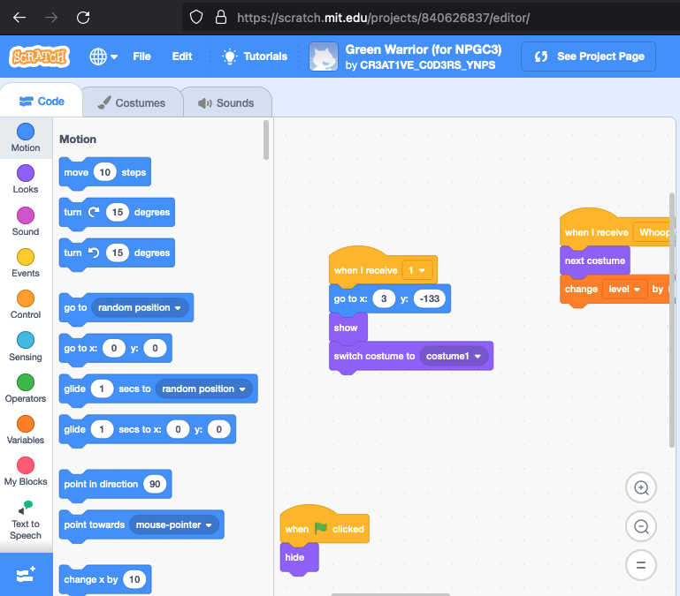

The provided screenshot showcases the visual block-style program in Scratch, where loops and if statements are used to control the game's execution flow. The intuitive and graphical nature of Scratch programming allows for easy understanding and manipulation of code logic.

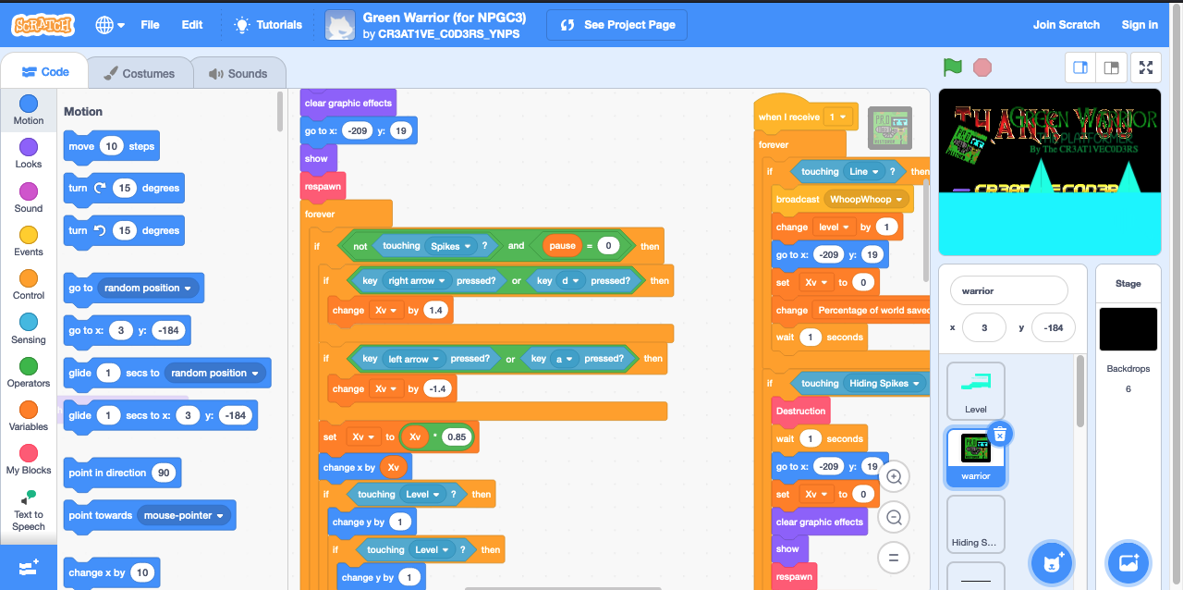

## 6. Acknowledgements

Creating "Green Warrior" was a labour of love, and we would like to express our heartfelt gratitude to everyone who supported us throughout this journey. We extend our appreciation to the following individuals and organizations:

* Our families and friends, for their unwavering support, encouragement, and understanding during the development process. Your belief in us fuelled our determination to bring this project to fruition.
* The judges and organizers of **NPGC3 (National Primary Games Creation and Coding Competition)** Singapore, for providing a platform where young minds can showcase their creativity and innovation. Your recognition of our efforts by selecting "Green Warrior" for the final rounds has been a tremendous honour.
* The Scratch programming community, for creating a platform that empowers young creators like us to turn our ideas into reality. The wealth of resources, tutorials, and shared projects have been instrumental in our learning and growth.
* Our mentors and teachers, for their invaluable guidance and support throughout the project. Your expertise and mentorship helped us overcome challenges, refine our ideas, and navigate the world of game development.
* The Scratch community, for sharing knowledge and resources that helped us expand our skills and enhance the game. Your contributions to the broader programming community have been instrumental in our learning journey.
* Last but not least, a special shoutout to our fellow team members. Each member played a crucial role in the development of "Green Warrior," bringing their unique skills, passion, and dedication to the project. The countless hours of collaboration, brainstorming, and hard work have truly made this game a team effort.

## 6. References

|  |  |
| --- | --- |
| URL | Remarks |
| <https://scratch.mit.edu/projects/840626837/fullscreen/> | Game Site |
| <http://npgcc.org/?page_id=58> | NGPC3 Announcement |
| <https://github.com/itti-ranjith/green-warrior> | Source Code |